Breadth First Search (BFS)

Aim:
To implement the Breadth First Search (BFS) algorithm in Python to traverse all the nodes of a graph level by level.

Objectives:
- To understand the concept of graph traversal.
- To implement BFS using Python.
- To use a queue for storing and processing nodes.
- To visit each node systematically level by level.
- To display the BFS traversal of the given graph.

Algorithm:
- Start with the given starting node.
- Create an empty visited set.
- Create a queue and insert the starting node.
- Remove the first node from the queue.
- If the node is not visited, mark it as visited and display it.
- Add all its unvisited adjacent nodes to the queue.
- Repeat steps 4–6 until the queue becomes empty.
- Stop the process.
Flow Chart:
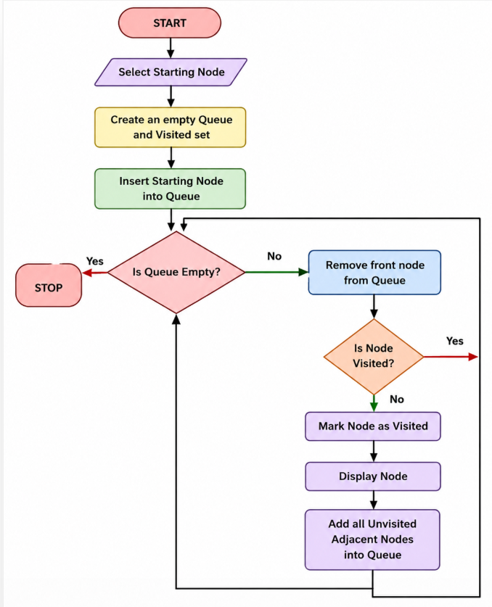
Code:
from collections import deque

def bfs(graph, start):
visited = set()
queue = deque([start])

while queue:
node = queue.popleft()

if node not in visited:
print(node, end=" ")
visited.add(node)

for neighbor in graph[node]:
if neighbor not in visited:
queue.append(neighbor)

graph = {
'A': ['B', 'C'],
'B': ['D', 'E'],
'C': ['F'],
'D': [],
'E': ['F'],
'F': []
}

print("BFS Traversal:")
bfs(graph, 'A')
Output:
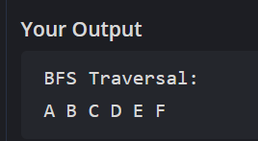

Result:
Thus, the Breadth First Search (BFS) algorithm was successfully implemented in Python, and the given graph was traversed level by level starting from node A.

